AEM Interview Questions:

1). AEM 6.3 features.

2). Explain AEM architecture

3). Parameters passed to execute() method of Workflow process.

4). How to get the page path with workitem parameter passed to execute() method of Workflow process.

5). Advantages of touch UI over Classic UI dialog

touch ui is mobile device friendly

its makes ur page responsive

insted of xtypes in touch ui we ll b making use of resourceType which is defined by granite ui

6). Explain different OSGI annotations

5). Different attributes of @Component annotation and explain their usage

7). Explain Sling resolution (Ex URL which they gave: <http://www.hcl.com?text=dcdsfd/sdfg>)

8). Have you done the load balancing in your project

9). Dispatcher concept, replication concept

10). Reverse replication concept

11). How to include header and footer in all the pages. Y cant u go with design dialog than iparsys.- irrespective of the template iparsys works

12). Different ways of registering Sling Servlet- with paths it should be registered in the config mrg

If we want to trigger a servlet in the component level give component path in the resource types i.e /apps/touchUI/components/content/slingServlet

13). How to call a third party service in sling servlet.

14). How to call a osgi service through JS

15). Different annotations of sling model class

16). Scaffolding -

1) Explain AEM technology stack?

2) Diff b/w Dialog and design-dialog?

3) How will you search <p> tag in the JCR? Using query in crxde tools

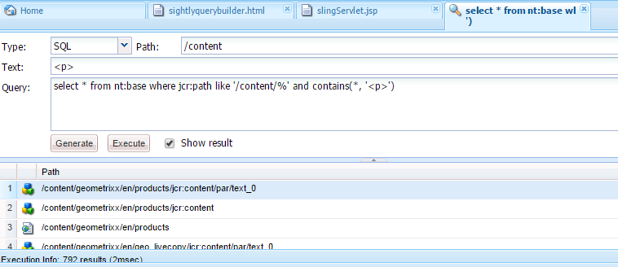

4) There are three templates, assume t1, t2 and t3. now There three levels of pages, assume Level 1 pages are creating using t1 template, L2 pages are creating by t2 and L3 used by t3. But some authors are creating L1 pages by using t3 and L2 pages are creating by t1 template by mistake. Now tell me how will you find those discrepancy pages programmatically.

5) Assume that there are three authors, one author is editing one component then how will you restrict others to allow editing on the same component. – lock page

6) Assume that there are 100 pages are published, now the client wants some changes across all the pages without authoring and publishing the pages then how will you do that? – querybuilder or workflow

7) Assume that there is a global page, under that there are language nodes, The language nodes may increase dynamically. Now tell me how will you populate those language node title in the dialog?

8) Have you worked on i18n? Explain?

9) Have you integrate with any translation connectors? Where will you change the field labels?

10) Have you worked on MSM?

11) There is a parent page A and child page B. In the page A, we need a dialog with textfield widget and in the page B, we need a dialog with pathbrowser widget but client wants only single component behaves like textfield/pathbrowser in the dialog. How will you achieve this? Using onload listener

12) How will you implement custom multi field?

13) How will you display the vanity URLs for all the pages? Assume that the authors are configuring vanity URLs under /apps and /etc then which will load first?

14) Have you worked on any Indexing and Versioning concepts?

15) How the search functionality works in AEM? How to display the last 5 searched keywords/history for logging Users.

16) What is DTM?

17) How to display the components or change the view of the page based on the users?

18) Is it possible to create a node in JCR from outside of AEM?

19) How will you get the node path based on the node property from the third party application(Outside of AEM)?

20) Is it possible to get the QuseryBulider object in the third party application?

21) Is it possible to connect with any data bases? If yes, then, while accessing the data from the Databases how will you create the Resource Resolver object?

22) How will you create a service from component?

23) How to create a servlet?

24) Have you worked on Workflows?

25) How to display the alert/error messages while uploading the assets in to the DAM?

26) Assume that there are two F1 and F2 folders in the DAM.

- F1 is the Admin folder which is accessible by only Admin.

- F2 is the custom folder which is accessible by only user A.

but once the custom folder reaches its capacity, then the assets will store in folder F1 automatically.

Q1) How will user A access F1 Folder.

Q2) What is impersonating?

Q3) How will you get Admin resolver and Admin session?

27) recursive method for reading child nodes?